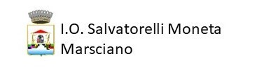
PROGRAMMA: ERASMUS +
AZIONE: KA1 “MOBILITA’ INDIVIDUALE AI FINI DELL’APPRENDIMENTO”
AMBITO: VET (Vocational Educational Training - Istruzione e formazione professionale)
PROGETTO: SWEET: Sustainability of Water Enviroment in Education and Traineeship
Prog. n° 2019-1-IT01-KA102-007184

contact Information
Name
Address
City, State, Zip Code
Phone Number
Email Address
Date
Salutation
Dear Mr./Ms. Last Name, (leave out if you don't have a contact)
First Paragraph
In the first paragraph, tell why you are writing.
Middle Paragraph(s)
Draw attention to anything in your background that would make you a viable candidate for the position. Amplify or clarify your specific achievements, , indicate how your experience or education fits the requirement of the position.
Final Paragraph
Conclude your application letter by thanking the employer for considering you for the position. Indicate your excitement or motivation for the position.
Complimentary Close
Sincerely,
Signature (Allow four spaces for your signature. And don't forget to sign in pen.)
Your Name

